Chapter 2: Rocks and minerals

2.1 Rocks have different properties

Student worksheet answers (pages 18–19)

Rock properties

1 Match the rock to its correct properties.

|  |  |  |  |  |  |  |  |
| --- | --- | --- | --- | --- | --- | --- | --- |
| 1 | L Fine grain, soft, light colour | 2 | P Fine grain, soft, light colour | 3 | N Fine or mixed grain, dark colour | 4 | E Coarse grain, hard, light colour |
| 5 | C Coarse grain, soft, light colour | 6 | D Fine grain, often larger crystals, light colour | 7 | J Fine grain, soft, dark colour | 8 | O Fine grain, soft, dark colour |
| 9 | K Medium to coarse grain, layers, splits easily | 10 | I Fine grain, dark colour | 11 | B Coarse grain, hard, light colour | 12 | A Fine grain, soft |
| 13 | G Mixed grain, hard or soft, colour varies | 14 | M Coarse grain, hard, light colour | 15 | H Fine grain, soft, dark colour | 16 | F Coarse grain, crystals in layers |

2 What is meant by the term ‘density’?

The heaviness or weight of the rock

3 What is the cause of colour in rocks?

The chemicals that the rocks are made up of

4 How are crystals different from grains?

Crystals are small pieces of organised particles that have smooth sides and sharp edges. They are one colour and reflect light off flat surfaces. Grains are small pieces of material, sometimes microscopic, are dull and are different colours.

5 Who am I? Use Table 2.1 and Figure 2.6 in your student book to name the following rocks.

a I am dark in colour, am soft and have a fine grain size. Some say I look like black glass.

Obsidian

b I have a course gain, am soft and light in colour. Sometimes I look pink and other times I look white.

Marble

c I am fine grained, have larger crystals and am light in colour. I am also very hard, with approximately one and a half times the density of water.

Rhyolite

Extend your understanding

6 Research to determine which rocks you would select for the following purposes.

a Bench top

Granite

b Production of energy

Coal

c The removal of dead skin

Pumice

d Roof tiles

Slate

e To produce cement

Limestone

2.2 Rocks are made up of minerals

Student worksheet answers (pages 20–21)

Classifying minerals

1 What is a mineral?

A naturally occurring solid substance with its own chemical composition, structure and properties

2 What is the main factor that influences the properties of a mineral?

Its structure and chemical composition

3 If graphite and carbon are both made of pure carbon, why do they look different?

Their atoms are arranged differently

4 Why is colour not a reliable property of a mineral on its own?

Because multiple minerals are the same or similar colours

5 Briefly explain each of the six characteristics that can be used to classify rocks.

Colour: the colours that make up the rock

Lustre: shininess

Transparency: how much light can pass through

Composition: what it is made of

Hardness: how easily it can be scratched

Cleavage: how rocks look when they break after being hit

6 What is the Mohr scale?

A scale of the hardness of a rock; 1 = soft, 10 = hard

7 Explain how Mohr knew that diamond was harder than talc.

Diamond can scratch talc

8 What is the hardest mineral on Earth? How would you know?

Diamond, because nothing can scratch a diamond

9 How would you know if a mineral was likely to demonstrate cleavage?

It would look like thin slabs of rock stuck together

10 Give an example of a rock that undergoes cleavage.

Answers will vary.

Mica – it breaks in one direction into flat layers

11 What are the three cleavage planes?

Left and right

Front and back

Top and bottom

Extend your understanding

12 Create a dichotomous key to identify the seven rocks below. You must use the properties of rocks and minerals discussed on pages 18–21. The key has been started for you.

|  |  |  |  |  |  |  |
| --- | --- | --- | --- | --- | --- | --- |
| Diamond | Quartz | Apatite | Amber | Fluorite | Pyrite | Sulfur |

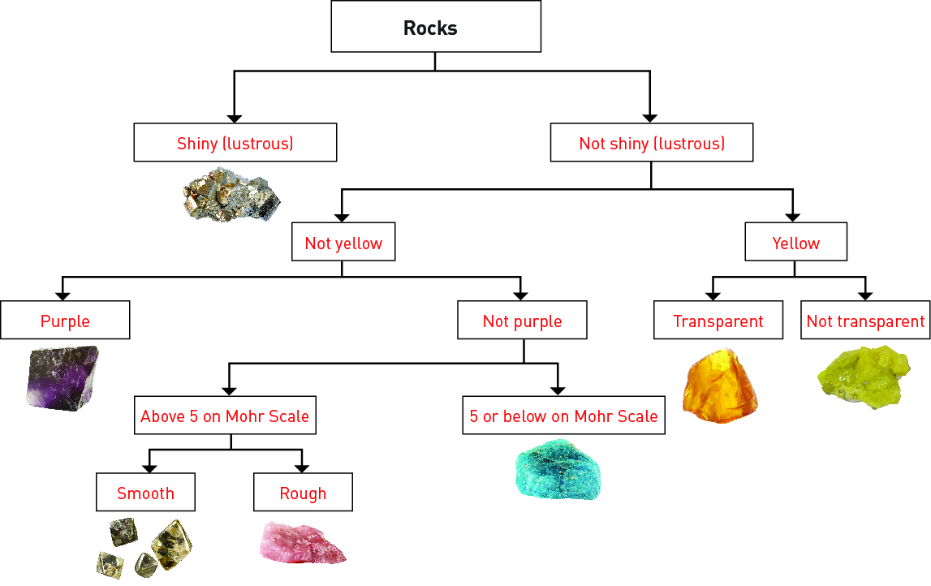

2.3 Minerals are a valuable resource

Student worksheet answers (pages 22–23)

Minerals as resources

1 What is an ore?

A mineral with a large amount of useful metal in it

2 Australia is the world’s highest producer of which seven minerals and ores?

Lead, bauxite (which produces aluminium), diamond, ilmenite, rutile, zircon, tantalum

3 Why is the worldwide demand for resources increasing?

Increased industrialisation due to increased population

4 When and where was gold first discovered in Australia?

In the 1850’s in Bathurst, New South Wales

5 Why is gold almost always found as pure gold?

It is chemically stable

6 What is gold used for?

Jewellery, wires, fillings for teeth, protection for satellites

7 What are mineral sands? What do they contain?

Old beach sands with significant concentrations of heavy minerals; these heavy minerals include rutile, zircon, and ilmenite

8 What form is copper in when it is mined in Australia?

Chalcopyrite

9 What is copper used for?

Electrical generators, motors, wires and electronic goods (such as televisions)

10 Which minerals are found in mobile phones?

Niobium and tantalum

11 Where are these minerals found?

In the Congo River Basin. Africa

12 What is a concern with mining these minerals?

It is destroying the habitat of animals in this region, especially endangered gorillas

Extend your understanding

Renewable and non-renewable resources are a big part of today’s society.

13 What is a renewable resource?

A resource that can be easily regenerated within a lifetime

14 What is a non-renewable resource?

A resource that takes millions of years to regenerate

15 Are minerals renewable or non-renewable? Explain your answer.

They are non-renewable as they are finite. There is a limited amount of these minerals and once used they cannot be regenerated in a short period of time.

16 What does this mean about our ability to mine minerals into the future?

We should be careful as these minerals are running out – try to find alternatives

17 What are two alternatives to mining new mineral resources out of the ground?

Use renewable resources such as tree/plant material, or recycle the old minerals that we no longer use

2.4 Igneous rocks develop from magma and lava

Student worksheet answers (pages 24–25)

Igneous rocks

1 What does the term ‘igneous’ mean?

The term ‘igneous’ comes from the Latin word *ignis,* which means ‘fire’.

2 What material is used to form an igneous rock?

Lava

3 What is the difference between lava and magma?

Magma is molten rock beneath ground; lava is molten rock above ground

4 How does an extrusive igneous rock from? Give an example.

Lava cools quickly on the surface of the Earth after a volcano erupts. It then solidifies into rock. E.g. Basalt

5 How does an intrusive igneous rock from? Give an example.

Magma cools and solidifies, before being pushed to the surface or being uncovered by erosion. E.g. Granite

6 What is the most common type of rock in the Earth’s crust?

Basalt

7 How are the following two types of this common rock formed and why do they look different to each other?

a Scoria

Scoria is full of bubble holes. The lava was filled with gases when it began to cool and the holes in the scoria are where the gas bubbles once were.

b Obsidian

Obsidian is a smooth, black rock that looks like glass. It is formed when lava cools almost instantly and forms no crystals.

8 Complete the following table to summarise the main differences between the formation of extrusive and intrusive igneous rock.

|  |  |  |
| --- | --- | --- |
|  | **Extrusive Igneous Rock** | **Intrusive Igneous Rock** |
| Formed by lava or magma? | Lava | Magma |
| Formed inside or outside of the volcano? | Outside | Inside |
| Method of cooling  (quick or slow)? | Quickly | Slowly |
| How does it reach the surface of the Earth? | It is already on the surface | Pushed to the surface or erosion |

9 Label the following diagram of a volcano.

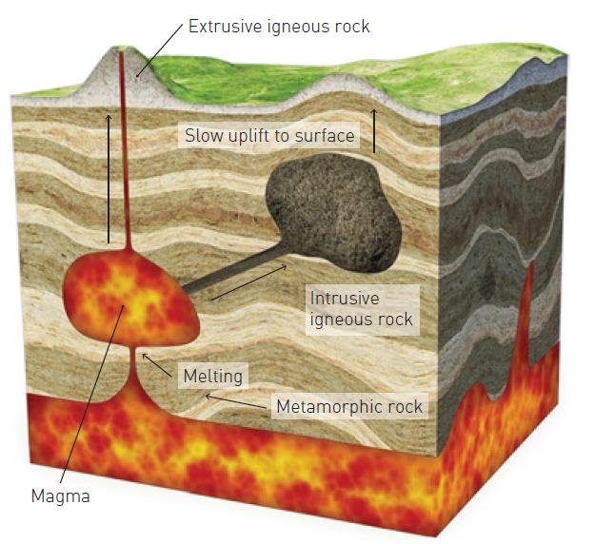

Extend your understanding

10 Research igneous rocks, find five examples, and complete the following table.

Answers may vary.

|  |  |  |  |
| --- | --- | --- | --- |
| **Name of Rock** | **Composition (what it is made of)** | **How it IS formed** | **function in the real world** |
| Pumice | Gas bubbles, volcanic glass and other materials | Forms during explosive eruptions and cools quickly to trap bubbles | Exfoliation – removes dead skin |
| Basalt | Pyroxene, plagioclase and olivine | Extrusive igneous rock | In the construction and road industries |
| Granite | Orthoclase, plagioclase and quartz | Intrusive igneous rock | Building – kitchen benchtops |
| Obsidian | Silicon, magnesium, iron, oxygen | Extrusive igneous rock | Used for blades |
| Diorite | Sodium-rich plagioclase with lesser amounts of hornblende and biotite | Intrusive igneous rock | Countertops, tiles, as a building material |

2.5 Sedimentary rocks are compacted sediments

Student worksheet answers (pages 26–27)

Sedimentary rocks

1 How are sedimentary rocks formed?

When particles of eroded rocks are compressed into layers over a long time

2 What are sediments? Give an example.

Particles of rock that erode, and are then transported and deposited by water and wind; for example, sand

3 Where do the sediments that form sedimentary rocks come from?

Eroded rocks

4 Explain the process of the formation of sedimentary rock using the following diagrams.

|  |  |
| --- | --- |
|  | Sediments are deposited in layers |
|  | The grains of sediment in lower layers begin to squash together |
|  | Chemicals that are dissolved in the water can soak into the sediments |
|  | The chemicals help cement the grains together once the water has evaporated |

5 What is an alternative method for the formation of sedimentary rock?

When water evaporates and leaves behind a solid substance, instead of chemicals seeping in

6 What is a fossil?

The imprints of an animal, plant, bacteria or other living organism preserved in rock

7 How is coal formed?

Dead plants are buried, covered in sediment, and then pressure compacts them into coal

8 Give an example of a sediment made from biological material and explain how it is used in the real world.

Coal; it is burned to form heat, which is then converted into electricity.

Extend your understanding

9 Research sedimentary rocks, find five examples, and complete the following table.

Answers will vary.

|  |  |  |  |
| --- | --- | --- | --- |
| **Name of Rock** | **Composition (what it is made of)** | **How it IS formed** | **function in the real world** |
| Coal | Carbon | Organic sedimentation – plants are pressurised into coal | Electricity |
| Limestone | Calcium carbonate | Organic sedimentation – from the accumulation of shell, coral, algal and faecal debris, which pressurise into limestone | Can be crushed into stone for construction, roads and railroads; used in concrete to make cement |
| Sandstone | Sand – usually quartz (silica dioxide), silt and clay | Clastic sedimentation – sand is deposited in layers, compacted down and chemicals bind/cement them together | Mined for use as a construction material or as a raw material used in manufacturing |
| Flint | Microcrystalline quartz | Chemical sedimentary rock – a chemical or biochemical rock that forms as nodules in sedimentary rocks | Used to make stone tools and start fires |
| Shale | Silt and clay-size mineral particles that we commonly call ‘mud’ | Clastic sedimentation – sand is deposited in layers, compacted down and chemicals bind/cement them together | Can produce natural gas or oil; can also produce clays |

2.6 Metamorphic rocks require heat and pressure

Student worksheet answers (pages 28–29)

Metamorphic rocks

1 How are metamorphic rocks formed?

When igneous, sedimentary or older metamorphic rocks are changed by intense heat and pressure inside the Earth

2 What does metamorphism mean?

Change in form

3 Where does the extreme heat come from?

The core of the Earth; the deeper you go, the hotter it gets

4 Where does the extreme pressure come from?

As sediments form on top of rock it pushes down, therefore the deeper the rock, the greater the pressure

5 What happens when pressure is uneven? What effect does this cause?

Rock crystals twist causing foliation

6 What feature of rocks changes when they are subjected to heat and pressure? Give an example.

Appearance (what it looks like) and chemical properties (change chemically); for example, granite may change to gneiss

7 What are index minerals?

Minerals that only form at high pressure and temperature

8 How is the rock gneiss formed?

When granite is squeezed under high pressure, the crystals change and the rock gneiss is formed

9 What properties does a metamorphic rock have that is different from an igneous or sedimentary rock? Why?

Metamorphic rocks are stronger than the original material because the particles have been fused together under great pressure or heat

Extend your understanding

10 Research the rock cycle and label the following diagram.

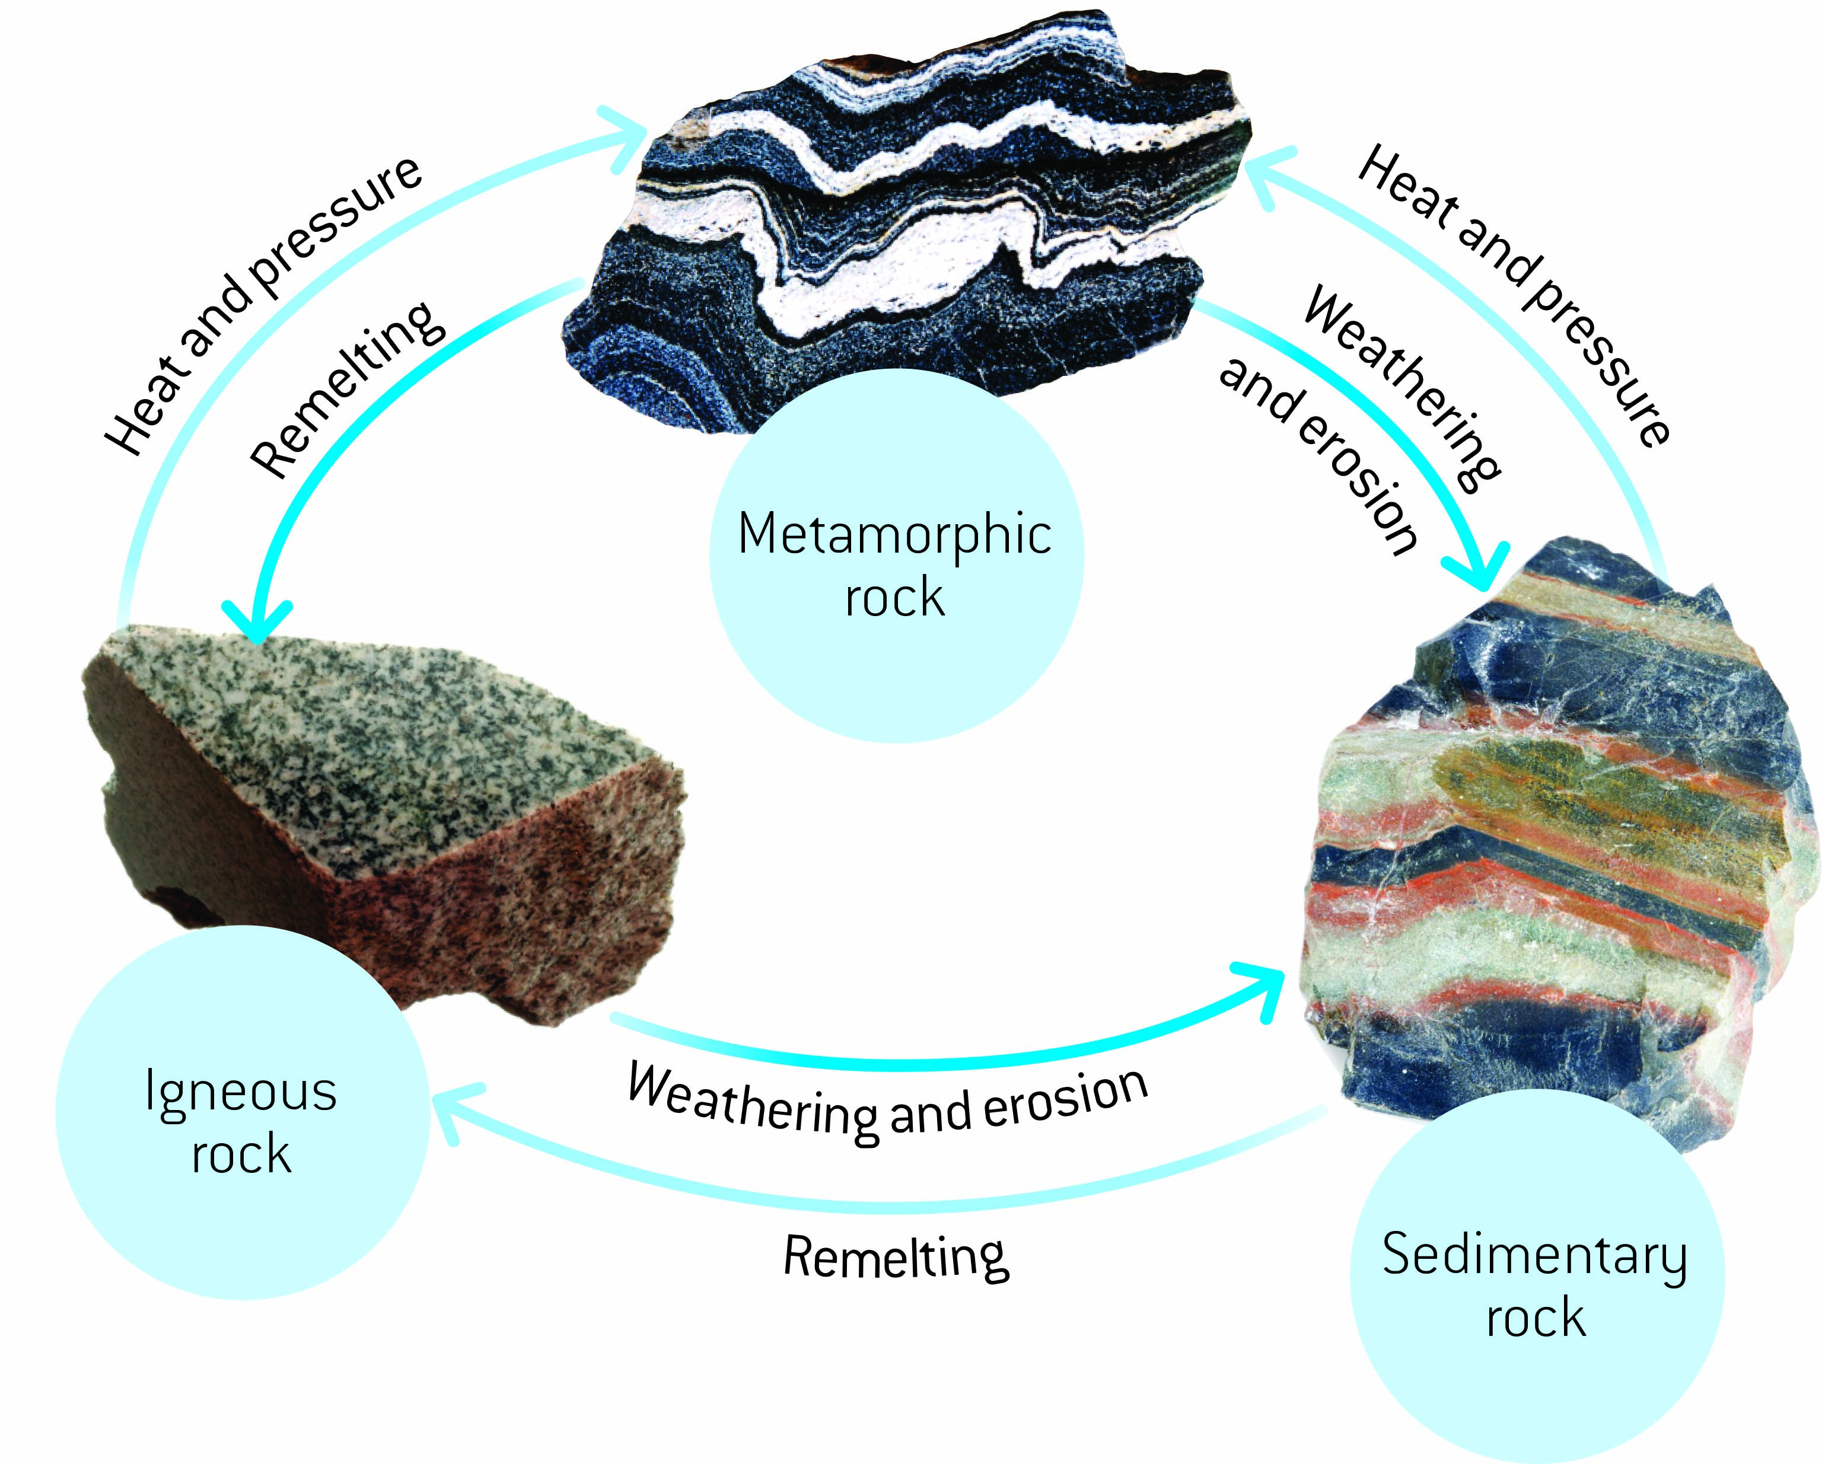

2.7 The rock cycle causes rocks to be re-formed

Student worksheet answers (pages 30–31)

The rock cycle

1 What is weathering?

The breaking down of rocks and minerals through the movement of water and animals, and the extremes of temperature

2 What is erosion?

The movement of the sediment to another area

3 How are physical weathering, chemical weathering and biological weathering different from one another?

Physical: occurs when a physical force is applied to break down a rock by non-living things

Chemical: occurs when a chemical is applied to break down the rock; e.g. acids (acid rain)

Biological: occurs when a biological organism breaks down the rock; e.g. a growing plant pushes on cracks

4 What is onion-skin weathering?

When the outside of a rock peels off

5 Which environment does onion-skin weathering occur in?

In deserts where extreme hot and cold conditions are experienced daily

6 What is frost shattering?

Water freezes inside a rock, expands, and pushes on surrounding rock. This push eventually breaks the rock.

7 Which environment does frost shattering occur in?

In cold environments where water can freeze, such as snowy environments

8 What chemicals are usually responsible for chemical weathering?

Carbon dioxide in the air turns into acid rain, which weathers rocks

9 What is responsible for biological weathering? Explain how this process occurs.

A seed can fall into a crack that has formed in a rock, and starts to grow. As the roots grow, they may force the rock to break down into sediment.

10 On Earth, where are temperatures greatest?

At the core of the Earth; deeper = higher temperature

11 On Earth, where is pressure at its greatest?

At the core of the Earth; deeper = more pressure

Extend your understanding

12 In a cartoon strip, explain the journey of a rock from the Earth’s surface, into the Earth and out through a volcano. You must describe all of the changes that happen to the rock and why, as well as all transformations that the rock undergoes.

Answers will vary, as will the pictures, but they should be similar to the following.

|  |  |
| --- | --- |
| A rock is on the Earth’s surface. | Sediments form on top of the rock causing it to sink deeper. |
| The rock gets hotter and experiences more pressure as it gets deeper – it turns into a metamorphic rock. | As temp keeps rising the rock becomes magma. |
| Magma will flow to a volcano where it will become lava as it exits the volcano. | When the lava cools it hardens to become an igneous rock. |

2.8 Science as a human endeavour: Weathering and erosion can be prevented

Student worksheet answers (pages 32–33)

Weathering and erosion

1 What is the role of a soil erosion engineer?

To prevent or slow down the rate of soil/rock erosion

2 Why is there a need for this type of engineering?

Humans have changed the environment, increasing the rate of erosion

3 What has happened to the population of Australia in the last 100 years?

It has increased by approximately 20 million (see student book Figure 2.34)

4 What result has this had on Australia’s waterways?

Increased population has increased the demand for roads and houses, which has involved removing trees from riverbanks and beaches, and decreasing vegetation at waterways

5 Why is the removal of plants from waterways causing soil erosion?

The plant roots don’t hold the soil together anymore and the topsoil erodes

6 What impact is soil erosion having on roads and buildings that are located near waterways?

Soil erosion can slowly remove the support beneath built structures, which may cause them to collapse

7 Explain why the event in the following picture occurred.

There are no plants with large roots on the coast. This means the soil was unstable when the path was built. The path crumbled when the soil eroded, as there were no plant roots holding it together.

8 Match each of the following engineering solutions to the corresponding explanation of how it works to solve an erosion problem.

|  |  |  |
| --- | --- | --- |
| **Engineering solution** |  | **Explanation** |
| 1 Control flow of water |  | C Minimises the erosion of farms and river banks |
| 2 Terraces |  | E Allows water to follow a set path that is protected from erosion by mad-made structures to minimise damage (e.g. drains) |
| 3 Grooves in cement |  | A Avoids temperature erosion that results in cracks |
| 4 Holes in bricks |  | F Allows water to move into the soil rather than contributing to run-off |
| 5 Groynes |  | D Prevents erosion of beaches caused by waves |
| 6 Regular cleaning |  | B Prevents moss build up that results in biological or chemical erosion |

Extend your understanding

9 Discuss the ways in which humans are responsible for

a weathering

Answers will vary. Examples include:

· Climbing on rocks (such as Uluru) weathers the rock

· Polluting the air with carbon dioxide causes acid rain

· Chipping away at rocks for building and sculptures breaks it apart

· Breaking rocks with explosives if they are in the way of development

b erosion

Answers will vary. Examples include:

· Removing vegetation makes the soil unstable and it erodes away

· Deforestation, watering and agriculture (erosion of topsoil)

10 Outline two possible solutions for

a man-made weathering

Stop polluting the atmosphere; do not cause damage to rock using man-made methods

b man-made erosion

Replant forests, coastlines and waterways; protect topsoil on agricultural land by planting more crops

2.9 Science as a human endeavour: Rocks are studied by geologists

Student worksheet answers (pages 34–35)

The work of geologists

1 How old is the Earth?

4.5 billion years old

2 What is a fossil?

The remains (or imprints) of animals or plants preserved in rock

3 Use the following diagrams to explain the steps involved in the formation of a fossil.

|  |  |
| --- | --- |
|  | If an organism dies near water, it has a greater chance of being covered by sediment. |
|  | The sediment protects the body from predators and weathering. |
|  | Over millions of years, more sediment is deposited and the remains are gradually transformed into sedimentary rock. |
|  | Years of geological movement, weathering and erosion may eventually expose the fossil. |

4 What is comparative dating?

Determining the age of rocks by comparing them to rocks of known age

5 Why is this called ‘comparative’ dating?

Comparisons are made between old and new rock, or between bottom and top layers

6 Why is the oldest rock at the bottom and the youngest rock at the top?

Newer rock sediments are deposited on top of older rock, and then even newer rock sediments are deposited on top of this, and so on. This results in the formation of layers of new rock down to old.

7 What are index fossils?

They are the same type of fossil found in different rocks that are the same age.

8 What is radioactive dating?

Determining the age of rocks by comparing the amounts of uranium and its decay product lead

9 Why are uranium and lead analysed in radioactive dating?

Uranium decays to lead at a known rate. By analysing how much uranium and lead is present in a rock, you can determine its age.

Extend your understanding

10 People who study geology at university perform many different roles in society. Research three geology occupations and explain what these people do in their careers.

Answers will vary. Examples include:

· Palaeontologists – They find, recover, date and study Earth’s fossils so they can build up a picture of the Earth’s history. This also allows them contribute evolutionary evidence as they are able to identify the organisms that were living in certain time periods.

· Mining/mineral geologists – They conduct studies to locate rocks that contain important metals, plan the mines containing these rocks and design methods to remove the metals from the rocks. They do similar work to locate and produce oil, natural gas and groundwater.

· Natural disaster geologists – They work to understand natural disasters such as earthquakes, volcanoes and floods so we can avoid building important structures where they might be damaged. If geologists can prepare maps of areas that have experienced disasters in the past, they can prepare maps of areas that might be affected in the future. They can predict where volcanoes might erupt and limit damage of earthquakes.